LESSON BOARD 2

- Revision of Verb “To BE” (Simple Present)
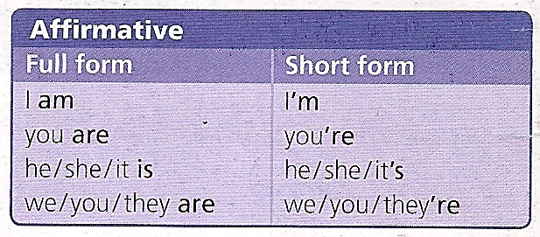

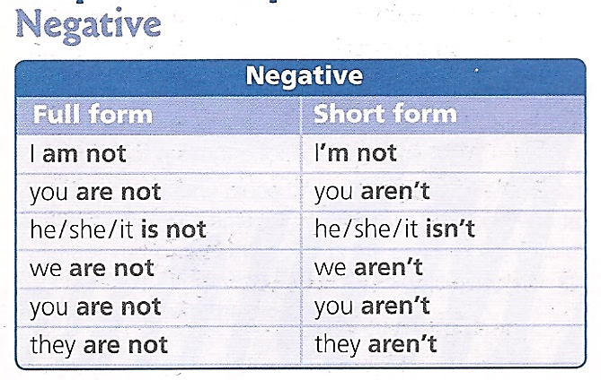

It - It´s – Its
My computer is new. It is expensive. (personal pronoun)
It´s expensive. It is …. (short form of “it is”)
Its memory is big. (possessive adjective) (my, your, his, her, its, our, your, their)

Some exercises: https://www.myenglishpages.com/english/grammar-exercise-be-present.php

- Practice: Personal Information Dialogue ( Word file in UTN:FRSF Campus)

PAIR WORK (HOMEWORK)

